# MED D - Early Refills/Plan Benefit Overrides (PBO) – CCR

[General Information](#_Toc92263401)

[Determining if an Override Is Allowed and Necessary](#_Toc92263402)

[Override Reference Table](#_Toc92263403)

[Adding Submission Clarification Codes](#_Toc92263404)

[Provider Lock](#_Toc92263405)

[Log Activity](#_Toc92263406)

[Resolution Time](#_Toc92263407)

[Related Documents](#_Toc92263408)

**Description:** This document provides information for the MED D Customer Care Representatives (CCRs) for processing the below types of overrides:

* **DC – Dosage Change**
* **DT – Duplicate Therapy**
* **LM – Lost Medications**
* **SM – Stolen Medication**
* **V – Vacation Meds**

**Note**: For all other override types, if you do not have PeopleSafe access to create overrides, or are not trained to process Med D overrides - transfer to the Senior Team or, if directed by the CIF, send an RM task.

* + Refer to [MED D - When to Transfer Calls to the Senior Team](file:///C:\Users\C337799\Downloads\TSRC-PROD-018060).

|  |
| --- |
| General Information |

Always review High Priority Comments from the Member Specific Utilization Management (MSUME) Team and verify if override requested is allowed per the Client Information Form (CIF) before moving on in this document.

**Note:** Overrides entered by the MSUME team should not be altered nor should an override bypass the MSUME’s override. Refer to [MED D - Member Specific Utilization Management Edit (MSUME)](file:///C:\Users\C337799\Downloads\CMS-PRD1-068281).

Customer Care representatives have the ability to provide **Submission Clarification Codes** (SCC) that will enable systematic overrides for Vacation, Dosage Change and Lost/ Stolen/Damaged medications.

 If an active PBO/Prior Authorization is in the system for the drug (ex. A Clinical PA), **do not enter an override.**

[Top of the Document](#_top)

|  |
| --- |
| Determining if an Override Is Allowed and Necessary |

If the caller is requesting an override, perform the following steps to determine if the beneficiary qualifies for the requested override:

|  |  |  |  |
| --- | --- | --- | --- |
| **Step** | **Action** | | |
| **1** | Determine the type of caller. | | |
| **If…** | **Then for…** | |
| Pharmacy | **Exception:** If you are trained to handle pharmacy calls, there is no need to transfer. Proceed to Step 2.  **Medicare D:** Warm transfer the pharmacy to the Pharmacy Help Desk at 1-866-693-4620. Refer to [Using the Phones / Aux / Hold / Warm Transfer](file:///C:\Users\C337799\Downloads\CMS-2-004567) for proper introduction and release of caller. | |
| Beneficiary or Authorized Party | Proceed to step 2.  Refer to [HIPAA Authentication Grid](file:///C:\Users\C337799\Downloads\CMS-2-028920). | |
| **2** | Review the Client Information Form (CIF) in theSource to determine if the override(s) is allowed. | | |
| **If the CIF…** | **Then…** | |
| Allows for specific PBO request or states CCR may enter override | Proceed to next step.  **Note: Rejection does NOT need to reject for today’s date in order to apply the override (same day rejection).**  If the CIF indicates pricing, copay, formulary adjustments, or any other financial requirements, transfer to the Senior Team to enter the override. Refer to [MED D - When to Transfer Calls to the Senior Team](file:///C:\Users\C337799\Downloads\TSRC-PROD-018060).  **Example:** Override allowed at $0 copay. | |
| States **AM Contact** to enter a PBO or to “CCR Submit PBO RM Task for Approval” | * CCR will Submit an RM Task if the beneficiary has a six-day supply or more on hand. * If less than six days on hand, transfer the call to the Senior Team to triage next steps for Client outreach. Refer to [MED D - When to Transfer Calls to the Senior Team](file:///C:\Users\u044748\AppData\Local\Temp\Temp1_Salesforce%20documents.zip\TSRC-PROD-018060). | |
| **DOES NOT** allow for specific plan benefit override request | Communicate to the caller that the plan does not allow for the specified override. If other options exist, advise the caller accordingly.  **Example:**  I apologize, the plan does not allow for the <override being requested>. Your plan will allow you to fill this medication on <steps to follow to obtain Rx). | |
| **3** | Determine if the beneficiary has an account/medication requiring the Senior Team to complete the override.   * EGWP with STCOB account * All NEJE EGWP accounts * Ophthalmic (eye) drop medication   https://www7.caremark.com/clt/caresource/image?url=http://prodcons.caremark.com/cons/groups/public/@cs/@spclaud/@public/documents/workinstruction/%7Eexport/CMS-PRD1-098488%7E5%7ECARESOURCE_DCTEMPLATE/224093-3.gif | | |
| **If...** | | **Then...** |
| Yes | | Transfer to the Senior Team to complete the override. Refer to [MED D - When to Transfer Calls to the Senior Team](file:///C:\Users\C337799\Downloads\TSRC-PROD-018060). |
| No | | Proceed to the next step. |
| **4** | Identify the type of override that is needed and verify that an override will resolve the issue by viewing the rejected claim for the medication. Refer to [Override Reference Table](#_Overview) for scenarios.  **Example:** Beneficiary is requesting a vacation supply or other early refill, there should be a rejected claim for Refill Too Soon or similar.  **Notes:**   * If related to **COVID-19 (Coronavirus), review the CIF** to ensure that we follow the client specific process.   + If the beneficiary or the pharmacy is calling, check the CIF to determine if the SCC-13 Code is an option.   + If the beneficiary or pharmacy is calling and the SCC-13 Code is NOT an option, check the CIF to see if Disaster Relief (DR) override code is mandatory.     - If CIF states to use override code DR and you do not have access, the plan has MChoice Incentivized, PA or QVT issues because of early refill or anything outside of early refill rejection not previously specified, follow your standard transfer process to the Senior Team. Refer to [MED D - When to Transfer Calls to the Senior Team](file:///C:\Users\C337799\Downloads\TSRC-PROD-018060). * If there is no client specific process:   + Determine if plan allows for a 90 day fill vs. 30 day fill. (**Example:** Maintenance Choice or Retail 90).   + Use code **RF – Override Refill Code** for 30 day or 90 day dependent upon Client Program Offerings. Refer to instructions on [Plan Benefit Overrides (PBO) CCR](file:///C:\Users\C337799\Downloads\CMS-2-024671).     - Calls using the RF Override Code should NOT be transferred to the Senior Team.     **Reminder:** When using the RF Override, add a note stating: **COVID-19**. | | |
| **If…** | **Then…** | |
| A rejected claim | 1. Access the Prescription Details and review the Reject Codes section. There will be codes and/or messaging to indicate why the claim is rejecting. 2. Ensure the codes/messaging reflects the issue at hand.   **Note:** A rejected claim is required so that the PBO can be entered with the specific NDC that the pharmacy is submitting which will avoid further rejected claims.   1. Move on to Step 5. | |
| No rejected claim | 1. Run a **Test Claim** (refer to [MED D - Test Claim](file:///C:\Users\C337799\Downloads\TSRC-PROD-021325)) to confirm the medication will reject. 2. Advise the caller that there must be a rejected claim present before a PBO can be entered.   **Notes:**   * For **retail** claims, the rejected Test Claim is not considered a rejected claim. We will need a rejected claim at the retail level to enter override. **Rejection does NOT need to reject for today’s date in order to apply the override (same day rejection).** Advise caller to have pharmacy run the claim and if it rejects, they can call the Retail Help Desk number located on the back of the beneficiary’s ID card to ask for an override. * If the beneficiary is escalated or out of medication, contact the pharmacy for the rejection. | |
| **5** | Check for [Submission Clarification Codes](#_Adding_Submission_Clarification). | | |
| **If there is...** | **Then...** | |
| A rejected claim | View Available Overrides option from Prescription Details screen.  **Result:** Displays Submission Clarification Codes (SCC) that are available and can include Vacation Supply, Lost/Stolen Medication, and Therapy Change overrides. It displays how many overrides, if any, are available, how many have been used, and any parameters set by the client. | |
| No rejected claim | After running a test claim, select Available Overrides option.  **Result:** Displays SCC overrides that are available and will include Vacation Supply, Lost/Stolen Medication, and Therapy Change overrides.  **Note:** This information is also available on the Plan Summary screen under Override Summary.  **Example:** Plan Summary Screen | |
| No SCC codes available | Proceed to Step 6. | |
| **6** | Review High Priority Comments to determine if there are any program or restrictions in place that would prevent the override.  (**Example:** Comment from Member Specific Utilization Management (MSUME) Team) | | |
| **7** | Confirm that a PBO for the situation at hand has not been entered or requested by completing the following:   * Review the **View Activity** screen to determine if an override has been requested. This may include PBOs requested by:   + Customer Care via the Plan Design/ Plan Benefit Override task   + Retail Help Desk via the Retail/ Client Directive task * Review the **Plan Benefit Override** screen to determine if an override has been entered in the system. * Review for previous overrides according to CIF limits, **Example:** 1 allowed per year.   **Icon - Important Information** If there is an active PBO/**Prior Authorization** (refer to [MED D - CCR - Coverage Determinations and Redeterminations (Appeals)](file:///C:\Users\C337799\Downloads\TSRC-PROD-004665)) in the system for the drug (**Example:** A Clinical PA), transfer to the Senior Team to enter the override. Refer to [MED D - When to Transfer Calls to the Senior Team](file:///C:\Users\C337799\Downloads\TSRC-PROD-018060).  **Note:** If there is suspicion of abuse, transfer to the Senior Team.  **Example:** Beneficiary has received multiple early refills for a controlled substance, possibly for different reason codes. | | |
| **8** | Enter appropriate override. Refer to [Override Reference Table](#_Overview). | | |

[Top of the Document](#_top)

|  |
| --- |
| Override Reference Table |

The following is a list of common scenarios MED D CCRs may encounter. Work Instructions are linked for each scenario type. Remember to always follow the instructions outlined in the plan CIF (Client Information Form) to verify all override options. If there is a concern with processing an override transfer to the Senior Team. Refer to [MED D - When to Transfer Calls to the Senior Team](file:///C:\Users\C337799\Downloads\TSRC-PROD-018060).

**Note:** Specialty medications can ONLY have overrides done by CCRs for the following reasons: Dosage change, Duplicate Therapy, Lost / Stolen / Damaged, Vacation Supply, Annual Fill Limit, Transform Care.

|  |  |  |  |
| --- | --- | --- | --- |
| **Scenario** | **Med D CCR Review Steps** | | **Work Instruction to Utilize** |
| Entering an Override with No Existing PA (Prior Authorization) on the account | * Review CIF to confirm override type requested by the beneficiary is allowed. * Check to see if a PA exists.   + If a PA exists on the account, transfer to the Senior Team. CCR should **not** place override when PA is on file.   + If no PA exists on the account, proceed with this scenario if allowed by the CIF * Run a Test Claim.   **Note:** Do not change the Refill Limit/DUR options back to N after entering the override or receiving a paid claim.   * Create override with NDC.   **Exceptions:** The ONLY times the GPI should be used to place an override are:   * When there is no rejected claim with Mail Order, or * For early refill requests for vacation supplies that can be made up to 30 days prior to departure * Run a Test Claim.   **Note:** Do not change the Refill Limit/DUR options back to N after entering the override or receiving a paid claim.  If Claim still rejects upon resubmission transfer to the Senior Team.  **Note:** If a beneficiary needs an override for a **mail order** due to travel, change in directions/dosage, or because it was lost/damaged/stolen, refer to [Plan Benefit Overrides (PBO) - CCR](file:///C:\Users\C337799\Downloads\CMS-2-024671). | | * [MED D - How to Identify a PA on Member's Account](file:///C:\Users\C337799\Downloads\CMS-PRD1-118050) * [Plan Benefit Overrides (PBO) - CCR](file:///C:\Users\C337799\Downloads\CMS-2-024671) * [MED D - Test Claims](file:///C:\Users\C337799\Downloads\TSRC-PROD-021325) |
| Entering an Override with an existing PA (Prior Authorization) on the account | * Check to see if a PA exists.   + If a PA exists on the account,     - NEJE: Warm Transfer to the Senior Team. CCR should **not** place override when PA is on file.     - All other clients: Transfer to the Senior Team. CCR should **not** place override when PA is on file.   + If no PA exists on the account, see information in the scenario above if allowed by the CIF.   Transfer to the Senior Team for overrides with an existing PA on the account. **Agent should not place the override.**  **Important:** If an active PBO/Prior Authorization is in the system for the drug (ex. A Clinical PA), **do not enter an override**.  Refer to [MED D - When to Transfer Calls to the Senior Team](file:///C:\Users\C337799\Downloads\TSRC-PROD-018060). | | * [MED D - How to Identify a PA on Member's Account](file:///C:\Users\C337799\Downloads\CMS-PRD1-118050) * [Plan Benefit Overrides (PBO) - CCR](file:///C:\Users\C337799\Downloads\CMS-2-024671) |
| B vs. D Claim Rejections | Check CIF to determine how client handles B vs D.  **Agent should not place the override.** | | Refer to the **Frequently Asked Questions** section of [Med D PHD – Medicare Part B vs D](file:///C:\Users\C337799\Downloads\CMS-PRD1-084075) |
| **If…** | **Then…** |
| Speaking with Pharmacist | Provide Pharmacist with the contact number listed within the rejected claim. |
| Speaking with  the Physician/  Doctor  OR  Beneficiary/authorized party  OR  3rd party, who is not an authorized party | Refer to [MED D - Coverage Determinations and Redeterminations (Appeals)](file:///C:\Users\C337799\Downloads\TSRC-PROD-004825). |

[Top of the Document](#_top)

|  |
| --- |
| Adding Submission Clarification Codes |

Follow the steps below when providing a Submission Clarification Code (SCC):

|  |  |  |
| --- | --- | --- |
| **Step** | **Action** | |
| **1** | Click the **Prescription Number** to display the **Prescription Details** screen for the rejected claim. | |
| **2** | Click on **Available Overrides** from **Prescription Details** screen.  C:\Users\UJ30FJ4\AppData\Local\Temp\SNAGHTML17320df.PNG  **Result: Override Summary screen displays.**    **Note:** If a section is blank below the specific override, the client has not adopted SCC code use. Review override section of the CIF. | |
| **If...** | **Then...** |
| The beneficiary is calling regarding the rejection and the override is available. | * Ask permission to place the beneficiary on hold while you call the pharmacy. * Call the pharmacy. * Ask them to enter SCC code on the beneficiary’s behalf.   + SCC Codes include:     - Vacation – 03     - Lost/Stolen/Damaged – 04     - Dosage/Therapy Changed – 05 * Remain on the line until the claim pays. * Proceed to Step 3. |
| Override Information is Displayed & requested override is available (Allowed > Used) | * Advise the pharmacy to resubmit the claim with the SCC Code:   + Vacation – 03   + Lost/Stolen/Damaged – 04   + Dosage/Therapy Changed – 05 * Stay on the line until the claim pays. * Proceed to Step 3. |
| Rejected Claim is received when an SCC code used | * Verify if beneficiary override limit exceeded (Allowed = Used) * Verify if Client does not support SCC codes (Reject 8R) * Verify if SCC Code used and resulted in an additional reject code   + 7X – Max Day supply – Direct pharmacy to resubmit claim to match DS allowed – Per screen below   + 78 – Review process for drug cost maximum – Per Screen below:      * Code used on other reject code (76, 19, 70) not eligible. Follow current process based on reject message. * Verify if Incorrect SCC code used based on override request (**Example:** 05 used for VA) Provide valid code and resubmit.   Icon - Important Information CCR’s are **NOT** required to review the CIF for these types of overrides and manually enter Plan Benefit Overrides based on these 3 new systematic overrides. **Reminder:** If one of these codes are input but the system has previously used all allowed occurrences, the claim will reject.   * If no SCC available, return to **Prescription Details** screen and move on to step 3. |
| **3** | Run a **Test Claim** (refer to [MED D - Test Claims](file:///C:\Users\C337799\Downloads\TSRC-PROD-021325)). If claim continues to reject, then transfer to the Senior Team. Refer to [MED D - When to Transfer Calls to the Senior Team](file:///C:\Users\C337799\Downloads\TSRC-PROD-018060).  **Note:** For Annual Fill Limit, reach out to filling pharmacy to ensure claim is reprocessed and paid. | |
| **4** | For **MOR PBOs**, proceed to Early Refills Mail Order section within the [Plan Benefit Overrides (PBO) CCR](file:///C:\Users\C337799\Downloads\CMS-2-024671) document once a **PBO** has been entered. | |

[Top of the Document](#_top)

|  |
| --- |
| Provider Lock |

View the Provider or Pharmacy lock out by selecting the **View Provider Lock** button. Provide the information to the beneficiary. If the beneficiary needs the medication and cannot go to the allowed pharmacy or provider, check CIF for override and transfer to the Senior Team if needed. Refer to [MED D - When to Transfer Calls to the Senior Team](file:///C:\Users\C337799\Downloads\TSRC-PROD-018060).

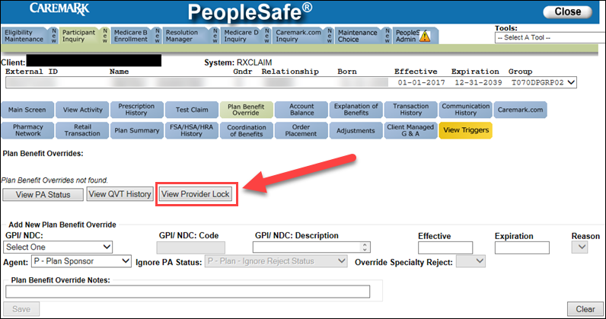

**Plan Benefit Override Screen in PeopleSafe**

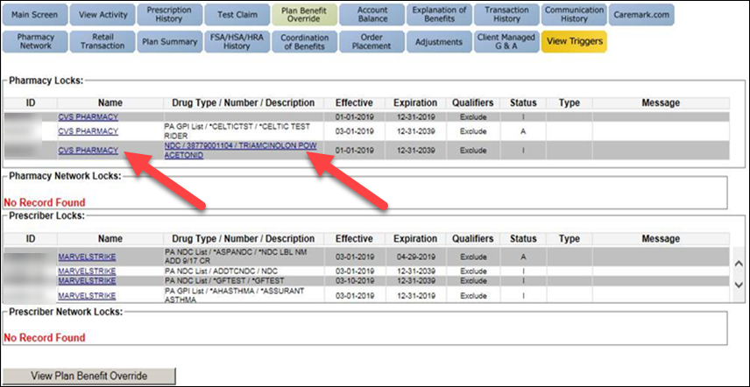

**New Provider Lock Screen**

* The **Name** and **Drug** links on new “Provider Lock” screen will lead to “Pharmacy Details” and “Drug Details” screens for additional pharmacy/drug information.

Icon_-_Important_Information Once on the “Provider Details” and “Drug Details” screens, the user can click the **Back** button to return to the “Provider Lock” screen.

* The **Effective** and **Expiration** fields indicate the date range of the lock in/out.
* The **Qualifier** field values indicate:
* Exclude = Exclusive overrides only
* Include = Inclusive overrides only
* The **Status** field values indicate:
* A = Active
* I = Inactive
* The **Type** field values indicate:
* A = Always
* P = Paid only
* R = Rejected only
* Blank = no value

**Prescriber and Pharmacy Lock In/Out:**

* Prevents ‘doctor shopping’ – A prescriber lock is entered on a member’s profile, locking into a particular prescriber. Claims from any other prescriber will reject.
* Prevents ‘pharmacy shopping’ – A pharmacy lock is entered on member’s profile, locking them into a particular pharmacy. Claims from any other pharmacy will reject.
* Can also prevent access to particular pharmacies or prescribers, or even lists of providers.
* Can also be limited to specific drugs. **Examples:**
  + Member A must always fill Drug Y at CVS on Main Street.
  + Claims for Drug Z written by Doctor B will always be denied.

[Top of the Document](#_top)

|  |
| --- |
| Log Activity |

PeopleSafe has the ability to auto-document the screens that are accessed by the CCR with the exception of the **Transmission** screen. Since the system will auto document the different screens, it is not necessary to use speed codes except 913 when you go to the **Transmission** screen.

[Top of the Document](#_top)

|  |
| --- |
| Resolution Time |

Real Time

[Top of the Document](#_top)

|  |
| --- |
| Related Documents |

**Parent SOP:** CALL-0048: [Medicare Part D Customer Care Call Center Requirements-CVS Caremark Part D Services, L.L.C.](https://policy.corp.cvscaremark.com/pnp/faces/DocRenderer?documentId=CALL-0048)

**Abbreviations/Definitions:** [Abbreviations / Definitions](file:///C:\Users\C337799\Downloads\CMS-2-017428)

[Top of the Document](#_top)

Not to Be Reproduced or Disclosed to Others without Prior Written Approval

**ELECTRONIC DATA = OFFICIAL VERSION / PAPER COPY = INFORMATIONAL ONLY**